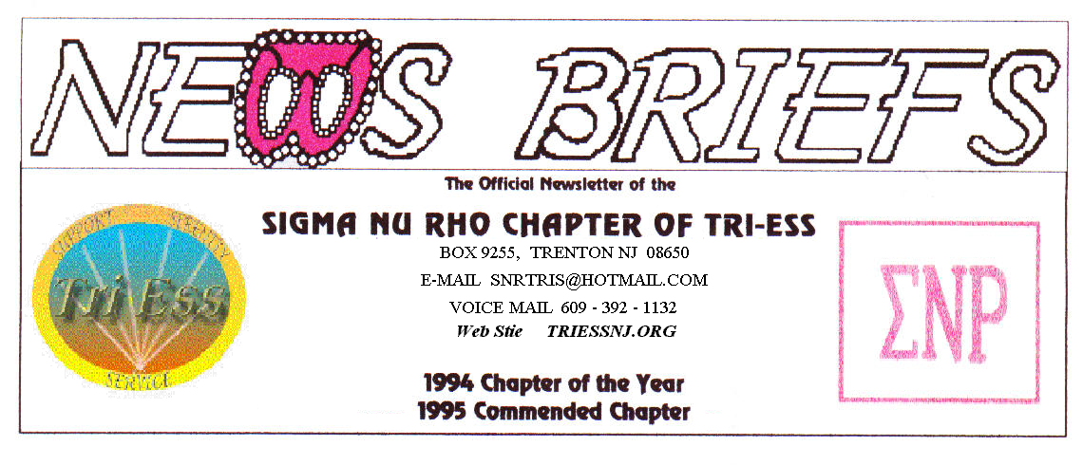
Published Dec. 2015
PARTY, PARTY, This Saturday Dec. 12

.
In The Burlington Room
START AT 7:00 P.M.
DINNER AT 8:00 P.M
ENDS BY 11:00 P.M.

Entrees

Sliced Roast Beef with mushroom
Gravy
Hawaiian Chicken
Sausage with Peppers and Onions
Stuffed Shells

Vegetable

Roasted New Potatoes
Glazed Carrots
String Beans Almondine

Appetizers

Franks in a Blanket
Buffalo Chicken Wings

You may bring a cake, pie or other dessert.
Bring a gift (about $20) it you want to be in the gift exchange. This is not required.
The cost will be the same as last year, $40.00 for members and $20.00 for wives. As always, you cannot bring another member and claim it is your wife without a marriage license.
You may bring a male guest, but he must pay for both of you! If you bring a girl friend, do not also bring your wife unless they are the same person.
NJ Support
A donation to the church will be discussed in January.
Lehigh Valley Meeting
December party/meeting.
King of Prussia
The Holliday Party Dec 19.
Weather Problems?
In the event of any question about a meeting for SNR or New Jersey Support, call 609-392-1132 for a recorded message. If the meeting is to be cancelled, there will be a recorded message to that effect.
REMEMBER
609-392-1132
FOR MEETING INFORMATION
New members
If you contact anyone who might want to come to a meeting, remember the basic requirement is that you meet them before you tell them where we meet. Any member can bring a guest or prospective new member but you must meet them in person first.

Glamour Boutique

Voucher Code to use on www.GlamourBoutique.com whenever you wish to place an order is:
PC10
There is no minimum; no date expiration and our members can use the code over and over. The Code should be ordered when checking out - there's a Voucher field and once you add in the Code the deduction will be made. Alternatively, we have our phones open 7 days a weeks and girls are free to call us on 1-888 721 8688 to place orders or to ask any questions regarding sizing or anything else.
www.GlamourBoutique.com
Tel: 973 226 5588 Fax: 973 226 5589

MEETING DATES

Nov. 21 Renaissance King of Prussia
Nov. 28 Sigma Nu Rho

Dec . 5 New Jersey Support NO MEETING
Dec. 12 Sigma Nu Rho PARTY
Dec. 12 Renaissance - Lehigh Valley
Pathways
Renaissance - Delaware
Dec. 19 Renaissance King of Prussia
PARTY
Dec. 26 Sigma Nu Rho NO MEETING
Sleep in day for Santa

HUMOR
Buying a Gun
I went over to the local Bass Pro Shop to get a small 9mm for home protection. When I was ready to pay for the gun and bullets, the cashier said,
"Strip down, facing me."
Making a mental note to complain to the NRA about the gun control wackos running amok, I did just as she had instructed. When the hysterical shrieking and alarms finally subsided, I found out she was referring to how I should place my credit card in the card reader!!!
I've been asked to shop elsewhere in the future. They need to make their instructions to seniors a little clearer.
I still don't think I looked that bad.

