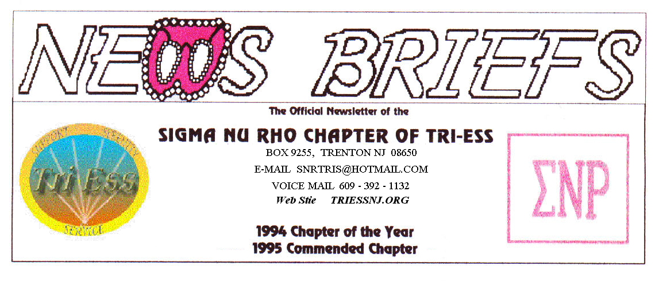
Published Nov. 2014
MEETING THIS SATURDAY
The Turkey is coming,
Can Santa be far behind?

The Adventures of Tammi
This month’s miss-adventure is titled “Tammi and the pantyhose”. Our heroine is attacked by three pair of vicious pantyhose but frees herself by running them. More details on request.
December Party
Come to the party December 13. I will not accept any excuse. If your ex is getting married that day, don’t go, just send the groom a condolence card and the name and address of a good divorce lawyer. Also remember to stop the alimony checks.
Please inform Pat ASAP if you intend to come to the party so she can reserve the correct number of seats.
The price will be as in the past, $40 per person with wives/friends at half price. If you are having a fight with your wife, she might not count as a friend and may have to pay full price.
In the event of any question about a meeting for SNR or New Jersey Support, call 609-392-1132 for a recorded message. If the meeting is to be cancelled, there will be a recorded message to that effect.

REMEMBER
609-392-1132
FOR MEETING INFORMATION
NJ Support
NO MEETING in December. The TriEss party will be the alternative.
Beginning in January there will be no meeting fee, just a contribution for the food.
Pathways
The November meeting was an introduction to the world of bondage and domination. Having been employed and a taxpayer most of my life, I feel I knew about this already. Only the method was a bit different and you can tell the other person to stop.
King of Prussia
The annual vendor’s night was slow, few vendors but not a bad turnout.
FIFTH SATURDAY
A Fifth Saturday is coming in November, any ideas of what to do?

New members
If you contact anyone who might want to come to a meeting, remember the basic requirement is that you meet them before you tell them where we meet. Any member can bring a guest or prospective new member but you must meet them in person first.

Glamour Boutique

Voucher Code to use on www.GlamourBoutique.com whenever you wish to place an order is:
PC10
There is no minimum; no date expiration and our members can use the code over and over. The Code should be ordered when checking out - there's a Voucher field and once you add in the Code the deduction will be made. Alternatively, we have our phones open 7 days a weeks and girls are free to call us on 1-888 721 8688 to place orders or to ask any questions regarding sizing or anything else.
www.GlamourBoutique.com
Tel: 973 226 5588 Fax: 973 226 5589

MEETING DATES

Nov. 22 Sigma Nu Rho
Nov. 29 Fifth Saturday

Dec. 6 New Jersey Support NO MEETING
Dec. 13 SNR PARTY
Pathways
Renaissance - Delaware
Renaissance - Lehigh Valley
Dec. 20 Renaissance King of Prussia
Dec. 27 Sigma Nu Rho NO MEETING

HUMOR
A man and a woman are seated next to each other on a flight. They start eyeing each other, and both realize they want to do the same thing. He slips a condom out of his pocket, and she looks delighted.
Rear toilet? He suggests. Five minutes, she agrees and goes off. He waits five minutes, then goes and slips in there with her. Right, get that condom on, she says. Soon, they are both sighing with pleasure.
But a sharp eyed stewardess has noticed them, and realized what they are up to, So, she humiliates them by making an announcement over the PA system. "To the lady and gentleman in the rear toilet, we know what you are doing, and it is expressly forbidden by airline regulations. Now, please put those cigarettes
out -- and take that condom off the smoke detector."
And what were you thinking?

