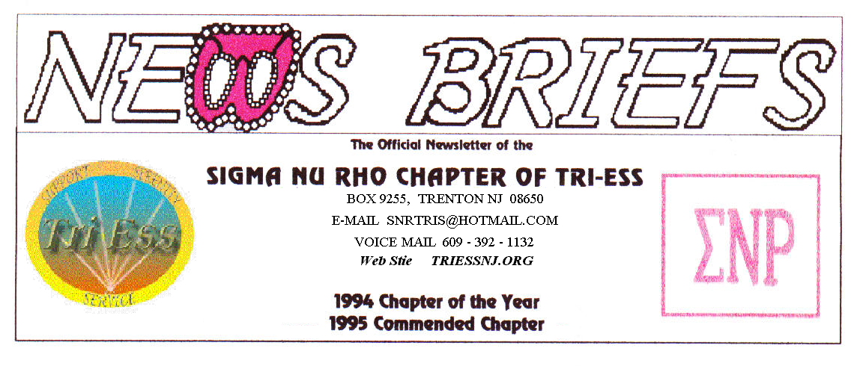
Published Sept. 2015
National Crossdresser’s Month

Well, OK, some people say its only one day not a month. Halloween parties go on almost all month and into the next month, so it is more than a month not just a day.
This year it is a Saturday, the FIFTH Saturday. What are we going to do about it? Sit home and give out candy to ruin kid’s teeth! NO! Let’s go out trick or treating, or at least go to the dinner in costumes. We can decide at the October meeting.
The summer has been slow with more republican candidates than members at the meetings. I hope more show up now that summer is over. The December party has to be planned, and I must get some idea of who will attend.
NJ Support
The September meeting was honored with the return of Tammi from her exile in Detroit. Will Detroit ever be the same? She will next be sent to re-organize Atlanta. Southern Bells will never ring the same, but if she dressed a Scarlet O’Hara, the south would be Gone With The Wind.
Lehigh Valley Meeting
Several new comers attended. The improvements to the website may be paying off.
There was some discussion of the Keystone Conference including the suggestion to reserve rooms before Oct. 1 as the rates got up after that date. You can cancel up to one week before the conference for a full refund.

King of Prussia
Dr. Michele Angelo gave a seminar of duality, be comfortable as both male and female. It was very interesting with a lot of audience participation.
The meeting was well attended, but it was unclear if the seminar or the cookout was the main attraction.
Next month is the Halloween Party.
Weather Problems ?
In the event of any question about a meeting for SNR or New Jersey Support, call 609-392-1132 for a recorded message. If the meeting is to be cancelled, there will be a recorded message to that effect.
REMEMBER
609-392-1132
FOR MEETING INFORMATION
New members
If you contact anyone who might want to come to a meeting, remember the basic requirement is that you meet them before you tell them where we meet. Any member can bring a guest or prospective new member but you must meet them in person first.

Glamour Boutique

Voucher Code to use on www.GlamourBoutique.com whenever you wish to place an order is:
PC10
There is no minimum; no date expiration and our members can use the code over and over. The Code should be ordered when checking out - there's a Voucher field and once you add in the Code the deduction will be made. Alternatively, we have our phones open 7 days a weeks and girls are free to call us on 1-888 721 8688 to place orders or to ask any questions regarding sizing or anything else.
www.GlamourBoutique.com
Tel: 973 226 5588 Fax: 973 226 5589

MEETING DATES

Sept 26 Sigma Nu Rho
Oct. 3 New Jersey Support
Oct. 10 Renaissance - Lehigh Valley
Pathways
Renaissance - Delaware
Oct. 17 Renaissance King of Prussia
Oct. 24 Sigma Nu Rho
Oct. 31 Halloween!

HUMOR

X wife
Tom finally decided to tie the knot with his longtime girlfriend. One evening, after the honeymoon, he was cleaning one of his hot rods for an upcoming show.
His wife was standing there at the bench watching him. After a long period of silence she finally speaks. "Honey, I've just been thinking, now that we are married maybe it's time you quit spending all your time out here in the garage and you probably should just consider selling all your cars along with your gun collection.
Tom gets this horrified look on his face. She says, "Darling, what's wrong?"
"There for a minute you were starting to sound like my ex-wife."
"Ex wife!”, she screams, "YOU NEVER TOLD ME YOU WERE MARRIED BEFORE!!!!!!!"
Tom's reply: "I wasn't.........."
Bob and Larry

Larry and Bob, two friends, met in the park every day to feed the pigeons, watch the squirrels and discuss world problems.
One day Larry didn't show up. Bob didn't think much about it and figured maybe he had a cold or something.. But after Larry hadn't shown up for a week or so, Bob really got worried. However, since the only time they ever got together was at the park, Bob didn't know where Larry lived, so he was unable to find out what had happened to him.
A month had passed, and Bob figured he had seen the last of Larry, but one day, Bob approached the park and -- lo and behold -- there sat Larry! Bob was very excited and happy to see him and told him so. Then he said, 'For crying out loud Larry, what in the world happened to you?
Larry replied, 'I have been in jail.'
'Jail!' cried Bob. What in the world for?'
'Well,' Larry said, 'you know Jane, that cute little blonde waitress at the coffee shop where I sometimes go?'
'Yeah,' said Bob, 'I remember her. What about her?
'Well, one day she filed rape charges against me; and, at 89 years old, I was so proud that when I got into court, I pleaded 'guilty'.
'The damn judge gave me 30 days for perjury.

