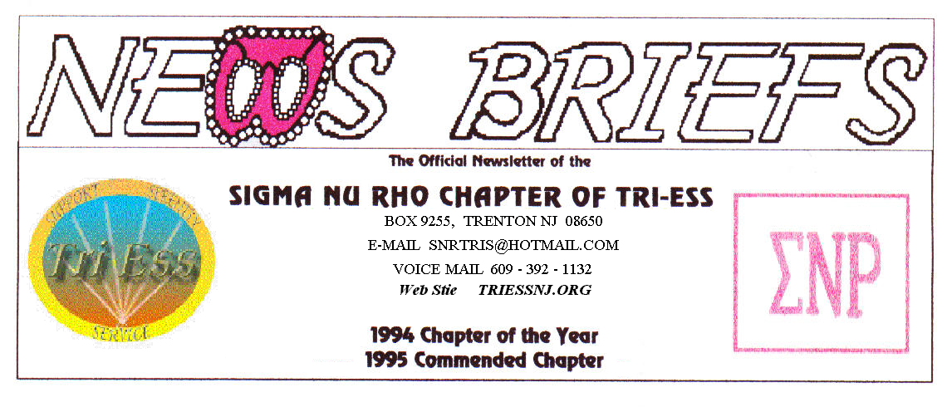
Published Feb. 2015
Pat has IMPLANT surgery.

Yes, on her birthday! Having investigated the new two step procedure and deciding it was for her.
Pat arrived at the surgeon’s office at 10:00 A.M. first step of the procedure that is done under local anesthesia. The first step is the actual implant with a second procedure after the original scars have had time to heal.
Being a tough old bitch, after two and one half hours of surgery, she drove herself and refused any pain medication afterward. She will be wearing a special cover-up to hide the initial phase until the final step is complete.
One of the benefits of this method is that it is done on an outpatient basis and is therefore less expensive and hopefully less painful in the long run.
She will be going back to the dentist for the crown in several months.
SNOW ?
In the event of any question about a meeting for SNR or New Jersey Support, call 609-392-1132 for a recorded message. If the meeting is to be cancelled, there will be a recorded message to that effect.
REMEMBER
609-392-1132
FOR MEETING INFORMATION

February MEETING
Nothing planned, but watch the weather. Hope to see you all.
NJ Support
The February meting went well? Except for the youth downstairs that would not stay there.
The food plan seems to be working, and a new girl arrived late thanks to a GPS problem. She hopes to get to the SNR meeting on the 28th.
King of Prussia
The meeting was canceled due to snow.
New members
If you contact anyone who might want to come to a meeting, remember the basic requirement is that you meet them before you tell them where we meet. Any member can bring a guest or prospective new member but you must meet them in person first.
Pathways
I did not attend the February meeting, and have no information about what happened. I only know that I was not there.

Glamour Boutique

Voucher Code to use on www.GlamourBoutique.com whenever you wish to place an order is:
PC10
There is no minimum; no date expiration and our members can use the code over and over. The Code should be ordered when checking out - there's a Voucher field and once you add in the Code the deduction will be made. Alternatively, we have our phones open 7 days a weeks and girls are free to call us on 1-888 721 8688 to place orders or to ask any questions regarding sizing or anything else.
www.GlamourBoutique.com
Tel: 973 226 5588 Fax: 973 226 5589

MEETING DATES
If snow permits!

Feb. 28 Sigma Nu Rho

Mar. 7 New Jersey Support
Mar. 14 Pathways
Renaissance - Delaware
Renaissance - Lehigh Valley
Mar. 21 NO Meeting due to Keystone
Mar. 28 Renaissance King of Prussia
Mar. 28 Sigma Nu Rho

HUMOR

John, who is now Jean, is walking down the street after a sex-change operation has transformed him into a beautiful woman.
His old friend Pete sees him and says, "John, I mean, Jean, you look great...you're beautiful!"
Jean says, "Thanks...but holy Christ, did it hurt."
Pete says, "When they cut open your chest and put in those implants?"
Jean says, "No, that didn't really hurt."
Pete says, "When they cut off your dick and dug out a vagina?"
Jean says, "No, that didn't really hurt."
Pete says, "Then what did hurt?"
Jean says, "When the doctor drilled a fucking hole in my head and sucked out half my brain."

*Female Medical Examination*
During a lady's medical examination, the British doctor says, "Your heart, lungs, pulse and blood pressure are all fine.
Now let me see the part that gets you ladies into all kinds of trouble."
The lady starts taking off her undies, but is interrupted by the doctor.
"No! No! .... Just stick out your tongue!"

