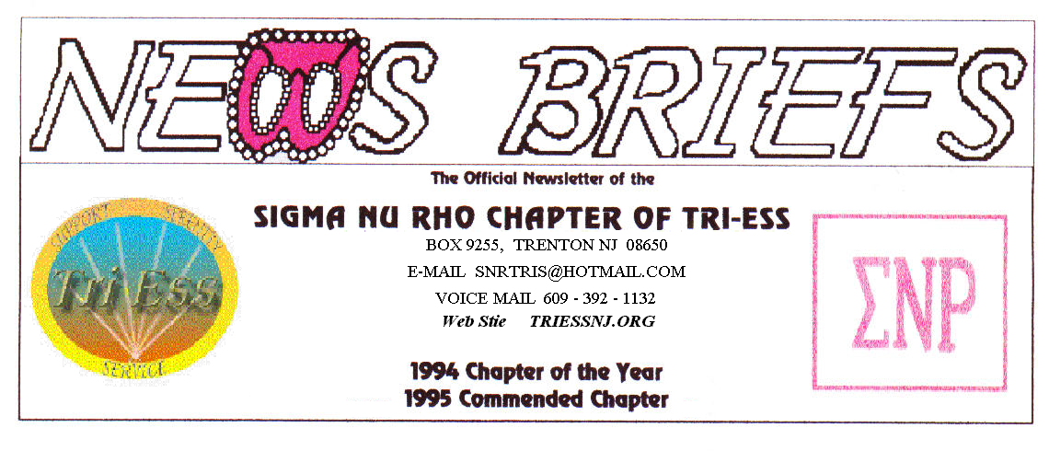
Published Jan. 2010
HAPPY NEW YEAR

POOL
The pool is CLOSED, at least until ice skating starts. Now that would be an idea. Who would want to try it?
FIFTH SATURDAY
The next is January 31, what are we going to do? Sending a crossdressed relief party to Haiti is not an option. We would not get past security. Boobs of mass destruction? Please support the relief in any other way you can.
Christmas Party?
A few ( eleven ) really determined (or just plain crazy ) people made it to the party. Pat, the head nut, drove down and back and lived to tell about it.
What we learned. First, have a contact list and backup plan for notification. Second, the hotel is a good idea because most of us could stay overnight.
I was thinking of Frenchtown. The rooms there are about $250.00 per night and the driving would be worse, so that would be a bad idea.
.
NJ Support
The January meeting had two new members, but the turnout was as lower than the temperature.

Tri-Ess National
Please give your Tri-Ess membership number to Pat or email it to her. We need a current list for Tri-Ess national. If your membership is not current, please renew it.
National News
There has been some action on the internet about Tri-Ess National. I will go over it at the meeting where I can answer questions.
Health
Get your shots (at the bar) and some vitamins, and be ready for winter. You may still get sick, but if you drink enough, you won’t care.
TriState Transgender
The January meeting was a football night. Stacy supplied the TV hookup with a laptop, and Pat supplied the projector. The Jets supplied a good start and the Eagles forgot how to fly. Maybe I should bring a Jets hat to the Philly meeting.
New Members??
If there is one area in which I fail, it is the area of membership. We do not seem to be getting any membership inquires by email, and the inquires we get all seem to be from girls who can’t get to the meeting due to business problems. It is nice to know that they are still working, but this does not help the meeting attendance. Our phone gets mostly telemarketing. Leah will be checking this.
I do not use any Internet chatrooms, and these might be a way to get new members. If any of you can help, please let me know
MEETING DATES

Jan. 2 New Jersey Support
Jan 9 TriState Transgender Support
Renaissance - Delaware
Renaissance - Lehigh Valley
Jan 16 Renaissance King of Prussia
Jan 23 Sigma Nu Rho
Jan 30 FIFTH SATURDAY
Feb. 6 New Jersey Support
Feb. 13 TriState Transgender Support
Renaissance - Delaware
Renaissance - Lehigh Valley
Feb. 20 Renaissance King of Prussia
Feb. 27 Sigma Nu Rho
Programs
ANY IDEAS????
Maybe we could do a field trip. Is there anyplace nearby worth going to? Becky was talking about golf, would this work? The pool should be ready and could be fun (wet tee shirts) or maybe a fancy dress night.

HUMOR
Two California Highway Patrol Officers were conducting speeding enforcement on I-15, just north of the Marine Corps Air Station at Miramar . One of the officers was using a hand held radar device to check speeding vehicles approaching the crest of a hill. The officers were suddenly surprised when the radar gun began reading 300 miles per hour. The officer attempted to reset the radar gun, but it would not reset and then it turned off.
Just then a deafening roar over the treetops revealed that the radar had in fact locked on to a USMC F/A-18 Hornet which was engaged in a low flying exercise near the location.
Back at the CHP Headquarters the Patrol Captain fired off a complaint to the USMC Base Commander. The reply came back in true USMC style:

Thank you for your letter. We can now complete the file on this incident..

You may be interested to know that the tactical computer in the Hornet had detected the presence of, and subsequently locked on to your hostile radar equipment and automatically sent a jamming signal back to it, which is why it shut down.
Furthermore, an Air-to-Ground missile aboard the fully armed aircraft had also automatically locked on to your equipment location.
Fortunately, the Marine Pilot flying the Hornet recognized the situation for what it was, quickly responded to the missile system alert status and was able to override the automated defense system before the missile was launched to destroy the hostile radar position.
The pilot also suggests you cover your mouths when cussing at them, since the video systems on these jets are very high tech.
Sergeant Johnson, the officer holding the radar gun, should get his dentist to check his left rear molar. It appears the filling is loose. Also, the snap is broken on his holster.

Thank you for your concern.

- Semper Fi

