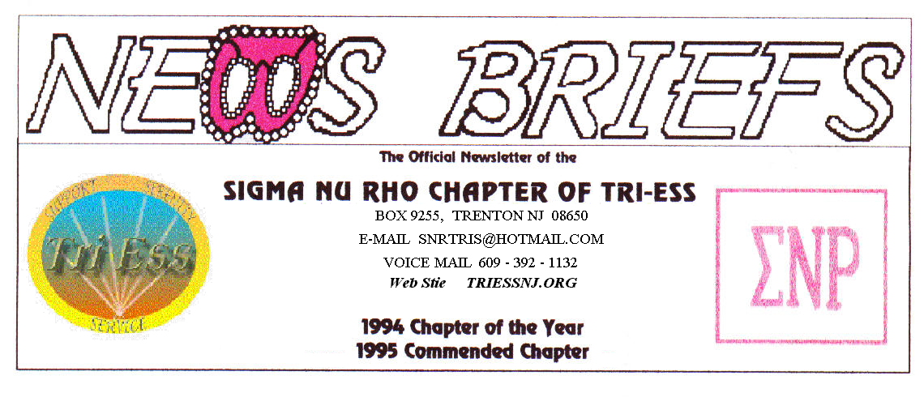
Published Mar. 2016
Spring!

SNR
There is an old movie called “Where the Boys Are”. My question is “Where are the girls?” Only FIVE made it to the meeting, but all five made it to the diner.
June and the PICNIC are coming. There have been some changes since last year that we will have to work on. One is Insurance. The church is requiring that we have insurance for the picnic.
The POOL should be opening soon, Time to get the suits out and shed a few pounds.
NJ Support
There was a very good turnout, a whole dozen with some new faces. Well not really, but one is going for facial surgery and will have a new face next time. REMEMBER NO MAY MEETING
Lehigh Valley Meeting
The new arrangement of the meeting procedure should be in effect.
The March meeting was on the THIRD SATURDAY, due to the Keystone Conference.
I was at the Philly meeting and missed it, due to my inability to bi-locate, I must work on that.
The Keystone Conference
The speaker for the Gala was great! Looking at her I was thinking, “She is young enough to be my GRAND DAUGHTER!”
My surprise arrival had one for our member in tears and almost disbelief.
King of Prussia
The highlight of the meeting was a demonstration of a hair removal method that looks like electrolysis, and is referred to as that. What I found on line is that it is a radio frequency treatment that hits the hair root with something like a microwave burst of energy. This means that not only can it treat all colors of hair, however, no electric current goes thru the body. This is a great idea if you have any heart problem, as it removes the risk heart involvement.
Weather Problems?
In the event of any question about a meeting for SNR or New Jersey Support, call 609-392-1132 for a recorded message. If the meeting is to be cancelled, there will be a recorded message to that effect.
REMEMBER 609-392-1132
New members
If you contact anyone who might want to come to a meeting, remember the basic requirement is that you meet them before you tell them where we meet. Any member can bring a guest or prospective new member but you must meet them in person first.
Glamour Boutique
Voucher Code to use on www.GlamourBoutique.com whenever you wish to place an order is:
PC10
There is no minimum; no date expiration and our members can use the code over and over. The Code should be ordered when checking out - there's a Voucher field and once you add in the Code the deduction will be made. Alternatively, we have our phones open 7 days a weeks and girls are free to call us on 1-888 721 8688 to place orders or to ask any questions regarding sizing or anything else.
www.GlamourBoutique.com
Tel: 973 226 5588 Fax: 973 226 5589

MEETING DATES
Mar. 26 Sigma Nu Rho
Apr. 2 New Jersey Support
Apr. 9 Renaissance - Lehigh Valley
Pathways
Renaissance - Delaware
Apr. 16 Renaissance King of Prussia
Apr. 23 Sigma Nu Rho
Apr. 30 NO MEETINGS
May 7 New Jersey Support NO MEETING
May 14 Renaissance - Lehigh Valley
Pathways
Renaissance - Delaware
May 21 Renaissance King of Prussia
May 28 Sigma Nu Rho

HUMOR

Ron was stopped by the police around
2 a.m. and was asked where he was
going at that time of night.
Ron replied, "I'm on my way to a lecture
about alcohol abuse and the effects it has
on the human body, as well as smoking and
staying out late."
The officer asked, "Really? Who's giving
that lecture at this time of night?"
Ron replied, "That would be my wife."

The elderly Irish virgin

In a tiny village on the Irish coast lived an old lady, a virgin and very proud of it.
Sensing that her final days were rapidly approaching, and desiring to make sure everything was in proper order when she dies, she went to the town's undertaker (who also happened to be the local postal clerk) to make proper 'final' arrangements. As a last wish, she informed the undertaker
that she wanted the following inscription engraved on her tombstone:
'BORN A VIRGIN, LIVED AS A VIRGIN, DIED A VIRGIN'
Not long after, the old maid died peacefully. A few days after the funeral, as the undertaker-- postal clerk went to prepare the tombstone that the lady had requested, it became quite apparent that the tombstone that she had selected was much too small for the wording that she had chosen He thought long and hard about how he could fulfill the old maid's final request, considering the very limited space available on the small piece of stone.
For days, he agonized over the dilemma. But finally his experience as a postal worker allowed him to come up with what he thought was the appropriate solution to the problem.

The virgin's tombstone was finally completed and duly engraved, and it read as follows:

RETURNED
UNOPENED

