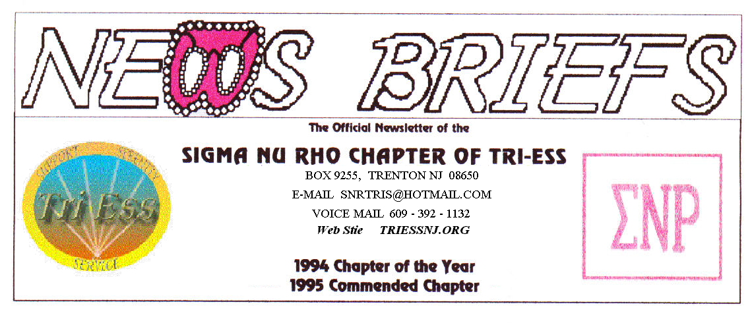
Published Nov. 2015
PARTY? Will there be a PARTY?

At this time, I have only FOUR members who have confirmed that they will attend the party on Dec. 12. It may already be to late to cancel the reservation, but I hope to at least move to a smaller room if the attendance is to be that low.
Not everyone gets the newsletter, and some will come without advanced notice, but I must have about fifteen confirmed to stay in the banquet hall. If you know anyone who might come to the party and can contact them, please ask them to email a reservation. A further problem is food service from the kitchen might not be available for the meeting room.
PLEASE, if you intend to come to the party, email me at snrtris@hotmail.com as soon as you can.
The current plan is
START AT 7:00 P.M.
DINNER AT 8:00 P.M
ENDS BY 11:00 P.M.
Bring a gift (about $20) it you want to be in the gift exchange. This is not required.
The cost will be the same as last year, $40.00 for members and $20.00 for wives. As always, you cannot bring another member and claim it is your wife without a marriage license.
You may bring a male guest, but he must pay for both of you! If you bring a girl friend, do not also bring your wife.

NJ Support
The November meeting was part discussion of December (NO MEETING IN DECEMBER) and part discussion of next year. There were eight members in attendance. A donation to the church will be discussed in January.
Lehigh Valley Meeting
A total of eighteen members and friends attended the November meeting. In what was to me the most strangest introduction, one member introduced her guest as “my soon to be ex-wife”.
After the normal round of discussions of individual’s months, the plans for the December party/meeting occupied the balance of the meeting.
King of Prussia
The Halloween Party was the theme of the meeting. This I also missed, as October was a busy month for me.
Weather Problems?
In the event of any question about a meeting for SNR or New Jersey Support, call 609-392-1132 for a recorded message. If the meeting is to be cancelled, there will be a recorded message to that effect.
REMEMBER
609-392-1132
FOR MEETING INFORMATION
New members
If you contact anyone who might want to come to a meeting, remember the basic requirement is that you meet them before you tell them where we meet. Any member can bring a guest or prospective new member but you must meet them in person first.

Glamour Boutique

Voucher Code to use on www.GlamourBoutique.com whenever you wish to place an order is:
PC10
There is no minimum; no date expiration and our members can use the code over and over. The Code should be ordered when checking out - there's a Voucher field and once you add in the Code the deduction will be made. Alternatively, we have our phones open 7 days a weeks and girls are free to call us on 1-888 721 8688 to place orders or to ask any questions regarding sizing or anything else.
www.GlamourBoutique.com
Tel: 973 226 5588 Fax: 973 226 5589

MEETING DATES

Nov. 21 Renaissance King of Prussia
Nov. 28 Sigma Nu Rho

Dec . 5 New Jersey Support NO MEETING
Dec. 12 Sigma Nu Rho PARTY
Dec. 12 Renaissance - Lehigh Valley
Pathways
Renaissance - Delaware
Dec. 19 Renaissance King of Prussia
PARTY
Dec. 26 Sigma Nu Rho NO MEETING
Sleep in day for Santa

HUMOR
A golfer was in a car accident and lost his arm.

He was taken to the hospital and just before he was put under, the surgeon dropped in to see him.

"I have some good news and some bad news" says the surgeon.

"The bad news is that I have to remove your right arm!"

"Oh God, no" cries the man, "My golfing is over. Please Doc what's the good news??;

"The good news is I have another one to replace it with but it's a woman's arm. I'll need your permission before I go ahead with the transplant."

"Go for it doc" says the man. "As long as I can play golf again."

The operation went well and a year later the man was out on the golf course when he bumped into the surgeon.

"Hi, how's the new arm?" asks the surgeon.

"Just great" says the businessman. "I'm playing the best golf of my life. My new arm has a much finer touch and my putting has really improved."

"Not only that" continued the golfer "my handwriting has improved, I've learned how to sew my own clothes and I've even taken up painting landscapes in water colors."

"Unbelievable" said the surgeon "I'm so glad to hear the transplant was such a great success. Are you having any side effects?"

"Well, there is just one problem" said the golfer. "Every time I get an erection I also get a splitting headache."

