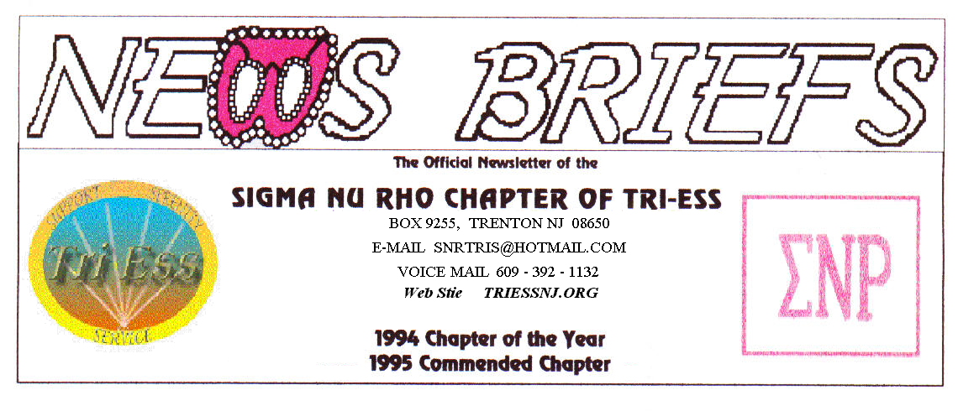
Published Jan. 2016
The Party’s Over

The party was good, but the attendance was not. Leah has suggested that we move the party to the first Saturday in December this year. If we do, should we still have a November meeting? Let’s talk about this very soon, I must reserve the hotel soon or lose the date.
NJ Support
A great meeting with a very good turnout for the NewYear. Let’s hope this continues,
Lehigh Valley Meeting
January started a new year with annual dues. For some strange reason, most came early and just sat and talked until the meeting started at eight. It was Tammi does Lehigh Valley night, so most of you know what that is like.
REMEMBER, the March meeting will be on the THIRD SATURDAY, due to the Keystone Conference.
King of Prussia
The party was great, but the aftermath was not. Someone stole most of the host’s heart medication, worth several hundred dollars.
Unfortunately, we must always remember that everyone is honest. Never leave valuables unattended at any meeting.

Weather Problems?
In the event of any question about a meeting for SNR or New Jersey Support, call 609-392-1132 for a recorded message. If the meeting is to be cancelled, there will be a recorded message to that effect.
REMEMBER 609-392-1132
New members
If you contact anyone who might want to come to a meeting, remember the basic requirement is that you meet them before you tell them where we meet. Any member can bring a guest or prospective new member but you must meet them in person first.
Glamour Boutique

Voucher Code to use on www.GlamourBoutique.com whenever you wish to place an order is:
PC10
There is no minimum; no date expiration and our members can use the code over and over. The Code should be ordered when checking out - there's a Voucher field and once you add in the Code the deduction will be made. Alternatively, we have our phones open 7 days a weeks and girls are free to call us on 1-888 721 8688 to place orders or to ask any questions regarding sizing or anything else.
www.GlamourBoutique.com
Tel: 973 226 5588 Fax: 973 226 5589

MEETING DATES

Jan. 23 Sigma Nu Rho
Jan. 30 FIFTH Saturday NO MEETINGS

Feb. 6 New Jersey Support
Feb. 13 Renaissance - Lehigh Valley
Pathways
Renaissance - Delaware
Feb. 20 Renaissance King of Prussia
Feb. 27 Sigma Nu Rho

Mar. 5 New Jersey Support
Mar. 12 Keystone Conference
Lehigh Valley next week
Pathways
Renaissance - Delaware
Mar. 19 Renaissance King of Prussia
Renaissance - Lehigh Valley
Mar. 26 Sigma Nu Rho

HUMOR

A couple were in a busy shopping center just before Christmas. The wife suddenly noticed that her husband was missing, and as they had a lot to do, she called him on his cell. The wife said, "Where are you? You know we have lots to do!"

He said, "You remember the jewelers we went into about 10 years ago, and you fell in love with that diamond necklace? I could not afford it at the time, and I said that one day I would get it for you."

Little tears started to flow down her cheek, and she got all choked up. "Yes, I do remember that shop." she replied.

"Well, I'm in the bar next to that."

