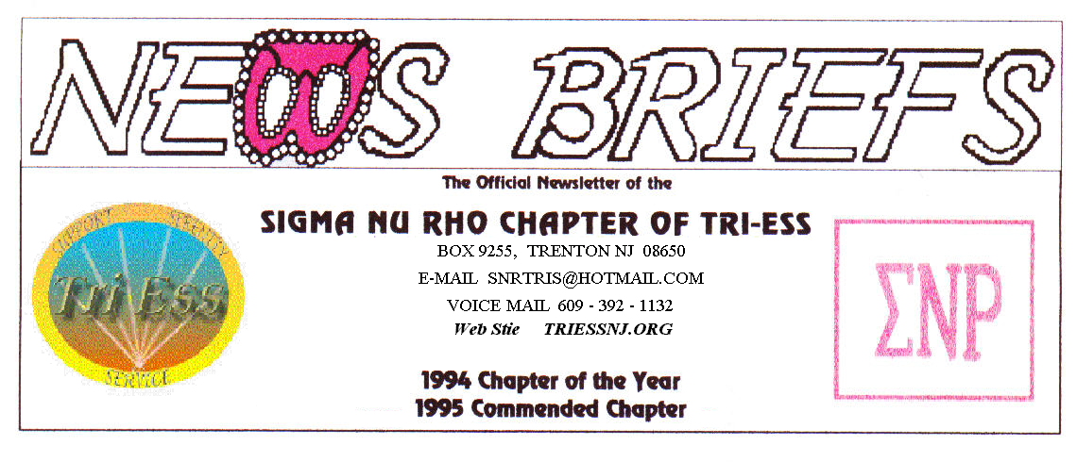
Published Oct. 2015
National Crossdresser’s Month

Well, this is it. It is the meeting of the year, costumes not required but welcome. Let’s have a good turnout and a great time.
This year Halloween is a Saturday, the FIFTH Saturday. What are we going to do about it? Sit home and give out candy to ruin kid’s teeth! NO! Let’s go out trick or treating, or at least go to the dinner in costumes. We can decide at this meeting.
The December party has to be planned, and I must get some idea of who will attend. If too few are coming to the party in December, we will move it to the regular meeting room to save some money. I hope that this does not happen.
NJ Support
The October meeting had some returning faces with people attached. One new member from September also returned. November will be the last meeting of the year as the church is not available in December.
Lehigh Valley Meeting
No news, I was not at the meeting. I will return in November.
King of Prussia
The Halloween Party was the theme of the meeting. This I also missed, as October was a busy month for me.
Weather Problems?
In the event of any question about a meeting for SNR or New Jersey Support, call 609-392-1132 for a recorded message. If the meeting is to be cancelled, there will be a recorded message to that effect.
REMEMBER
609-392-1132
FOR MEETING INFORMATION
New members
If you contact anyone who might want to come to a meeting, remember the basic requirement is that you meet them before you tell them where we meet. Any member can bring a guest or prospective new member but you must meet them in person first.

Glamour Boutique

Voucher Code to use on www.GlamourBoutique.com whenever you wish to place an order is:
PC10
There is no minimum; no date expiration and our members can use the code over and over. The Code should be ordered when checking out - there's a Voucher field and once you add in the Code the deduction will be made. Alternatively, we have our phones open 7 days a weeks and girls are free to call us on 1-888 721 8688 to place orders or to ask any questions regarding sizing or anything else.
www.GlamourBoutique.com
Tel: 973 226 5588 Fax: 973 226 5589

MEETING DATES

Oct. 17 Renaissance King of Prussia
Oct. 24 Sigma Nu Rho
Oct. 31 Halloween!

Nov. 7 New Jersey Support
Nov. 14 Renaissance - Lehigh Valley
Pathways
Renaissance - Delaware
Nov. 21 Renaissance King of Prussia
Nov. 28 Sigma Nu Rho

Dec . 5 New Jersey Support NO MEETING
Dec. 12 Sigma Nu Rho PARTY
Dec. 12 Renaissance - Lehigh Valley
Pathways
Renaissance - Delaware
Dec. 19 Renaissance King of Prussia
PARTY
Dec. 26 Sigma Nu Rho NO MEETING
Sleep in day for Santa

HUMOR
Businessman worrying about his wife being "lonely".......

A businessman was preparing to go on a long business trip, so he thought he'd buy his wife something to keep her occupied. He went to a sex shop and explained his situation.

The man there said, "Well, I don't know that I have anything that will
keep her occupied for so many weeks, except...The Magic Penis!"

The husband said, 'The what'?

The man repeated, 'The Magic Penis,' and pulled out what seemed to be an ordinary dildo.
The husband laughed, and said, 'It looks like a dildo!'

The man then pointed to the door and said, ' Magic Penis, door!'

The penis rose out of its box, darted over to the door and started
pounding away at the keyhole. The whole door shook wildly with vibrations, so much so, that a crack began to form down the middle. Then
the man said, 'Magic Penis, return to box!' and the penis stopped and
returned to the box.

The husband bought it and took it home to his wife. After the husband
had been gone a few days, the wife remembered the Magic Penis. She undressed, opened the box and said 'Magic Penis, my vagina.'

The penis shot to her crotch. It was absolutely incredible. After three
mind shattering orgasms, she became very exhausted and decided she'd had
enough. She tried to pull it out, but it was stuck. Her husband had neglected to tell her how to turn it off so she put her clothes on, got in her car and started for the closest hospital.

On the way, another incredibly intense orgasm made her swerve all over
the road. A Police Officer saw this and immediately pulled her over. He
asked for her license, and then asked how much she'd had to drink.

Gasping and twitching, the woman said, 'I haven't had anything to drink
officer. You see, I've got this Magic Penis thing stuck in my crotch and it won't stop screwing me.'

The officer looked at her for a second, shook his head and replied,
'Yeah right... Magic Penis, my ass...!!!'

The rest, as they say, is history...

