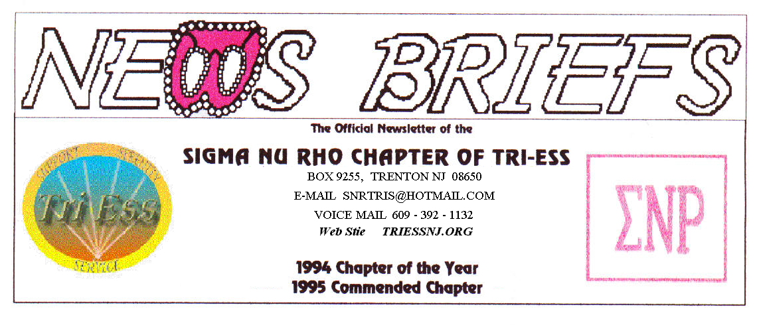
Published May 2015
Plans for the Picnic

Spring
Let’s get ready to start those diets right after the picnic so we can wear those new swimsuits in the pool in July and August.
April MEETING
Some of the plans for the picnic were discussed, but a few things still need to be worked out. The basic arrangements should be the about the same as last year.
Setup starts about 3PM, Food should be ready about 4 PM and cleanup starting around 6:30. The price will still be $10.00 per person, and any food that you wish to donate will be welcome.

Weather Problems ?
In the event of any question about a meeting for SNR or New Jersey Support, call 609-392-1132 for a recorded message. If the meeting is to be cancelled, there will be a recorded message to that effect.
REMEMBER
609-392-1132
FOR MEETING INFORMATION
NJ Support
There was no meeting in May, and there will be no meeting in July.

King of Prussia
Dr. Michele Angelo was scheduled to speak this month, but called in very ill not could not come. She will try again at a future date.
Several new members arrived, and the total turnout was very good.
Lehigh Valley Meeting
The meeting was a general discussion with emphasis on the upcoming move to a new location.
The Pride Day was also a topic of discussion.
The June meeting will be the annual cookout.
New members
If you contact anyone who might want to come to a meeting, remember the basic requirement is that you meet them before you tell them where we meet. Any member can bring a guest or prospective new member but you must meet them in person first.

Glamour Boutique

Voucher Code to use on www.GlamourBoutique.com whenever you wish to place an order is:
PC10
There is no minimum; no date expiration and our members can use the code over and over. The Code should be ordered when checking out - there's a Voucher field and once you add in the Code the deduction will be made. Alternatively, we have our phones open 7 days a weeks and girls are free to call us on 1-888 721 8688 to place orders or to ask any questions regarding sizing or anything else.
www.GlamourBoutique.com
Tel: 973 226 5588 Fax: 973 226 5589

MEETING DATES

May 16 Renaissance King of Prussia
May 23 Sigma Nu Rho
May 30 Fifth Saturday

June 6 New Jersey Support
June 13 Renaissance - Lehigh Valley
Picnic
Pathways
Renaissance - Delaware
June 20 Renaissance King of Prussia
June 27 Sigma Nu Rho PICNIC

July 4 New Jersey Support NO MEETING
July 11 Renaissance - Lehigh Valley
Pathways ? May not meet.
Renaissance - Delaware
July 18 Renaissance King of Prussia
July 25 Sigma Nu Rho

HUMOR

TWO NUNS
There were two nuns...

One of them was known as Sister Mathematical(SM), and the other one was known as Sister Logical (SL).

It is getting dark and they are still far away from the convent.

SM: Have you noticed that a man has been following us for the past thirty-eight and a half minutes? I wonder what he wants.
SL: It's logical He wants to rape us.
SM: Oh, no! At this rate he will reach us in 15 minutes at the most! What can we do?
SL: The only logical thing to do of course is to walk faster.
SM: It's not working.

SL: Of course it's not working. The man did the only logical thing. He started to walk faster, too.
SM: So, what shall we do? At this rate he will reach us in one minute.
SL: The only logical thing we can do is split. You go that way and I'll go this way. He cannot follow us both.

So the man decided to follow Sister Logical.
Sister Mathematical arrives at the convent and is worried about what has happened to Sister Logical.
Then Sister Logical arrives.

SM: Sister Logical! Thank God you are here! Tell me what happened!
SL: The only logical thing happened. The man couldn't follow us both, so he followed me
SM: Yes, yes! But what happened then?
SL: The only logical thing happened. I started to run as fast as I could and he started to run as fast as he could.
SM: And?
SL: The only logical thing happened. He reached me
SM: Oh, dear! What did you do?
SL: The only logical thing to do. I lifted my dress up.
SM: Oh, Sister! What did the man do?
SL: The only logical thing to do. He pulled down his pants.

SM: Oh, no! What happened then?
SL: Isn't it logical, Sister?
A nun with her dress up can run faster than a man with his pants down.

And for those of you who thought it would be dirty,
I'll pray for you!

