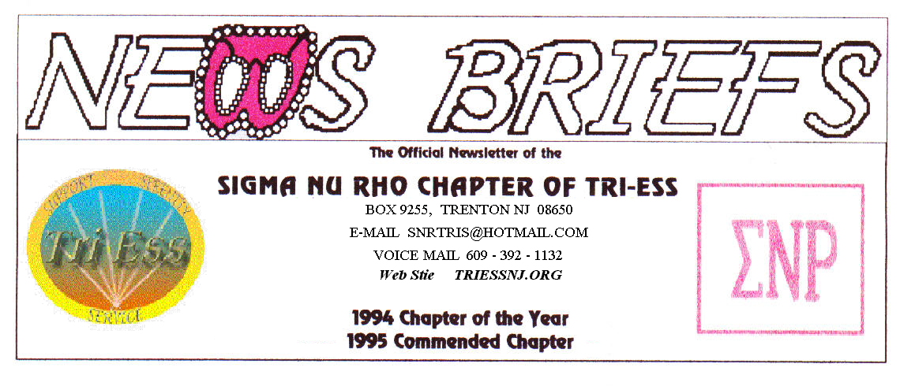
Published Mar.2014
Happy St. Patrick’s Day

SNR
There is a chance that the snow may end in time for the picnic in June. If it does not, remember the church is heated and we can eat inside. The cook might want to start looking for a warmer coat and a bigger fire. Should the snow get too deep, remember to call before digging the car out of the snow bank.
In the event of any question about a meeting for SNR or New Jersey Support, call 609-392-1132 for a recorded message. If the meeting is to be cancelled, there will be a recorded message to that effect.
REMEMBER
609-392-1132
FOR MEETING INFORMATION
New members
If you contact anyone who might want to come to a meeting, remember the basic requirement is that you meet them before you tell them where we meet. Any member can bring a guest or prospective new member but you must meet them in person first.
FIFTH SATURDAY
The Fifth Saturday seem to be coming back. Let’s look forward to March 29.

NJ Support
The March meeting was well attended but caused some problems with the church. A church member was in the building and overheard part of a conversation. There was an objection to the language and or topic. Some of the members also seemed to be upset about the conversation. Proper, lady like deportment should be a goal at all meetings.
REMINDER, there is normally no meeting in May
Pathways
The lingerie program was a success, with Pat acting as the model for a bra fitting. (She might not have been on her breast behavior.)
Next month will include an outing to a local watering hole (gin mill). DWI checks may be the order of the evening.
King of Prussia
The program was on hair and skin.
A further program for May was discussed that will be in the afternoon. I will try to let you know when and if the regular evening meeting will still be held.

Glamour Boutique

Voucher Code to use on www.GlamourBoutique.com whenever you wish to place an order is:
PC10
There is no minimum; no date expiration and our members can use the code over and over. The Code should be ordered when checking out - there's a Voucher field and once you add in the Code the deduction will be made. Alternatively, we have our phones open 7 days a weeks and girls are free to call us on 1-888 721 8688 to place orders or to ask any questions regarding sizing or anything else.
www.GlamourBoutique.com
Tel: 973 226 5588 Fax: 973 226 5589

MEETING DATES

Mar. 22 Sigma Nu Rho
Mar. 29 Fifth Saturday – No Meetings
Apr. 5 New Jersey Support
Pathways
Apr 12 Renaissance - Delaware
Renaissance - Lehigh Valley
Apr. 19 Renaissance King of Prussia
Apr. 26 Sigma Nu Rho

HUMOR

Recently, a female sheriff's deputy arrested Patrick Lawrence, a 22 year old white male, who was fornicating with a pumpkin in the middle of a field at night. The next day, at the Gwinnett County (GA) courthouse, Lawrence was charged with lewd and lascivious behaviour, public indecency and public intoxication.
The suspect explained that he was passing a pumpkin patch on his way home from a drinking session when he decided to stop. 'You know how a pumpkin is soft and squishy inside, and there was no one around for miles, or at least I thought there was no one around' he stated.
Lawrence went on to say that he pulled over to the side of the road, picked out a pumpkin that he felt was appropriate to his purpose, cut a hole in it, and proceeded to satisfy his pressing need. 'Guess I was really into it, y'know?' he commented with evident embarrassment.
In the process of doing the deed, Lawrence failed to notice an approaching sheriff's car and was unaware of his audience until Deputy Brenda Taylor approached him.

'It was an unusual situation, that's for sure,' said Deputy Taylor. 'I walked up to Lawrence and he's just humping away at this pumpkin.'
Deputy Taylor went on to describe what happened when she approached Lawrence...
'I said: 'Excuse me sir, but do you realize that you're having sex with a pumpkin?'
He froze and was clearly very surprised that I was there, and then he looked me straight in the face and said:
'A pumpkin? Shit ... is it midnight already?'
The court (and the judge) could not contain their laughter. Lawrence was found guilty only of public intoxication, fined $10. and sent on his way.
The Washington Post wrote an article describing this as "The best come-back line ever."
----------------------------------------------------------------

Back on January 9th, a group of Pekin , Illinois bikers were riding west on I-74 when they saw a young woman about to jump off the Murray Baker Bridge. A small crowd had gathered, so they stopped.
George, their leader, a big burly man of 53, gets off his Harley, walks through a group of gawkers, past the State Trooper who was trying to talk her down off the railing, and says,

"Hey, Babe... whatcha doin' up there on that railin'?"
She says tearfully, "I'm going to commit suicide!!"

While he didn't want to appear "sensitive," George also didn't want to miss this "be-a-legend" opportunity either so he asked ..."Well, before you jump, Honey-Babe...why don't you give ole George here your best last kiss?"
So, with no hesitation at all, she leaned back over the railing and did just that ... and it was a long, deep, lingering kiss followed immediately by another even better one.
After they breathlessly finished, George gets a big thumbs-up approval from his biker-buddies, the onlookers, and even the State Trooper!

Now gloating proudly, and still enjoying the moment, George presses on, and declares so all can hear him, "Wow! That was the best kiss I have ever had, Honey! That's a real talent you're wasting, Sugar Shorts. You could be happy, if you rode with me! Why the hell are you committing suicide?"

"My parents don't like me dressing up like a girl."

It's still unclear whether she slipped, or was pushed.

