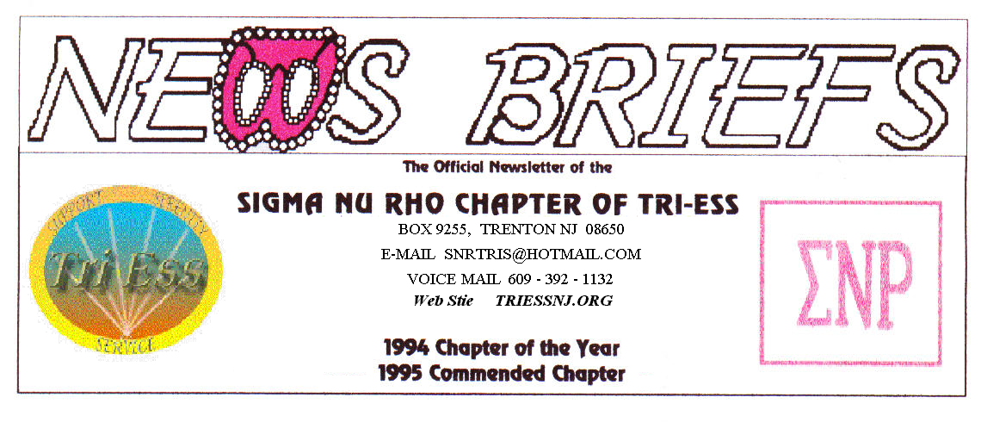
Published Mar. 2015
NO MORE SNOW, PLEASE!

With the weather changing, I hope, it is time to think about the picnic and the swimsuit outing. Lets start those diets so we all look good this summer. It might even be a good idea to learn how to swim!
Last month we all went to the dinner, and Melody showed up, late as usual. We had a great time and will do it again when everyone wants to go.
March MEETING
Nothing planned, but watch the weather. Hope to see you all.
SNOW ?
In the event of any question about a meeting for SNR or New Jersey Support, call 609-392-1132 for a recorded message. If the meeting is to be cancelled, there will be a recorded message to that effect.
REMEMBER
609-392-1132
FOR MEETING INFORMATION
NJ Support
The March meeting was not well attended, but we enjoyed it anyway. Let’s hope April will be better.
Remember, there will be no meeting in May.

King of Prussia
The meeting postponed due to Keystone.
Lehigh Valley Meeting
There was a clothing swap this month, and the Keystone Conference was discussed. Pat (Gown Pat) talked about her problems with credit card fraud.
I brought Jill to the meeting to get help with a local doctor for hormones, as she is new to the area having recently moved from the Morristown NJ area.
Pathways
I did not attend the March meeting, and have no information about what happened. I only know that I was not there.
New members
If you contact anyone who might want to come to a meeting, remember the basic requirement is that you meet them before you tell them where we meet. Any member can bring a guest or prospective new member but you must meet them in person first.

Glamour Boutique

Voucher Code to use on www.GlamourBoutique.com whenever you wish to place an order is:
PC10
There is no minimum; no date expiration and our members can use the code over and over. The Code should be ordered when checking out - there's a Voucher field and once you add in the Code the deduction will be made. Alternatively, we have our phones open 7 days a weeks and girls are free to call us on 1-888 721 8688 to place orders or to ask any questions regarding sizing or anything else.
www.GlamourBoutique.com
Tel: 973 226 5588 Fax: 973 226 5589

MEETING DATES

Mar. 28 Renaissance King of Prussia
Mar. 28 Sigma Nu Rho

Apr. 4 New Jersey Support
Apr. 11 Pathways
Renaissance - Delaware
Renaissance - Lehigh Valley
Apr. 18 Renaissance King of Prussia
Apr. 25 Sigma Nu Rho

HUMOR
Dentist Chuckle
A man goes to a female dentist to have a tooth extracted.
She pulled out a large syringe to give an anesthesia shot.
"No way, no needles! I hate needles!" the man exclaimed.
So she started to hook up the nitrous oxide tank, and the man said, "I can't do the gas thing. Just the thought of having a mask on my face suffocates me!
The dentist then asked the patient if he had any objections to taking a pill.
"No," he says, "I'm fine with pills."
So the dentist gave him two little blue pills and he swallowed them.
"What are those?" he asked.
"Viagra," she replied.
"I'll be damned," said the patient, "I didn't know Viagra worked as a pain killer."
"It doesn't," said the dentist, "But it will give you something to hold on to when I pull your tooth."

Sven and Ole

Sven and Ole worked together in a Minnesota factory.....and both were laid off. So...dey went to da Unemployment Office togedder.

Asked his occupation, Ole said, "Panty Stitcher.. I sew da elastic onto da ladies cotton panties." The clerk looked up Panty Stitcher. Finding it classified as unskilled labor, she gave Ole $300 a week in unemployment compensation.??

Sven, when asked his occupation replied, "Diesel Fitter". The clerk looked up Diesel Fitter...and it was classified as a skilled job. So, the clerk gave Sven $600 a week in unemployment compensation.

When Ole found this out, he was furious! He stormed back into the office to find out why his friend and co-worker was collecting double his benefits.

The clerk explained, "Panty Stitchers are unskilled labor and Diesel Fitters are skilled labor."

"Vat skill? yelled Ole. "I sew da elastic on da panties. Sven puts dem over his head and says, "Yah, ------------- DIESEL FITTER".

