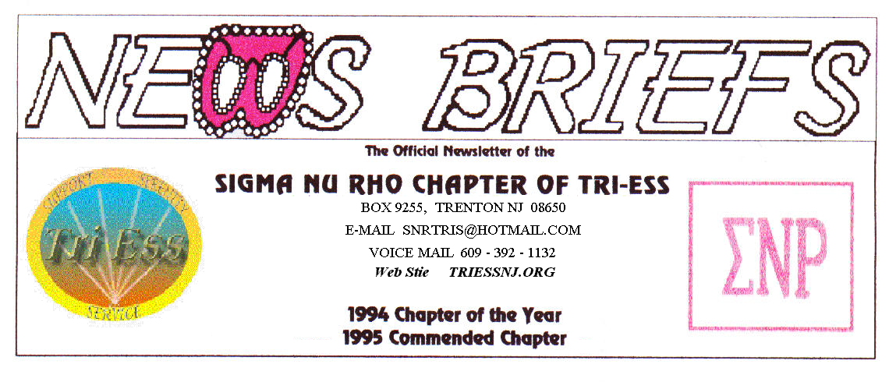
Published July 2015
THE POOL, Bring your suits!

PICNIC
Well, it rained! We still came with our appetites and had a good time. Stacy may be part mermaid, but she did not have to worry about melting like the wicked witch in the Wizard of Oz.
The pool should be open for the brave members of the group.

Weather Problems ?
In the event of any question about a meeting for SNR or New Jersey Support, call 609-392-1132 for a recorded message. If the meeting is to be cancelled, there will be a recorded message to that effect.
REMEMBER
609-392-1132
FOR MEETING INFORMATION
NJ Support
There was not July meeting. See you in August

King of Prussia
.
Again several new members arrived. They are coming thru a meetup group in PA.
Nothing special at the meeting, there was no program, but the announcements were interesting.
First, the sex federal discrimination law has been revised to include transgender. (In PA they can fire you for being trans, but you can now sue under federal discrimination law)
Second, Dr. Michelle Angelo will be here in Sept. along with the cook out. She will speak in living two lives for those of us who cannot transition.
Lehigh Valley Meeting
The July meeting was the last in their current location. New site opens in August.
The turnout was small, but the program on equal rights in PA. was interesting.

New members
If you contact anyone who might want to come to a meeting, remember the basic requirement is that you meet them before you tell them where we meet. Any member can bring a guest or prospective new member but you must meet them in person first.

Glamour Boutique

Voucher Code to use on www.GlamourBoutique.com whenever you wish to place an order is:
PC10
There is no minimum; no date expiration and our members can use the code over and over. The Code should be ordered when checking out - there's a Voucher field and once you add in the Code the deduction will be made. Alternatively, we have our phones open 7 days a weeks and girls are free to call us on 1-888 721 8688 to place orders or to ask any questions regarding sizing or anything else.
www.GlamourBoutique.com
Tel: 973 226 5588 Fax: 973 226 5589

MEETING DATES
July 4 New Jersey Support
July 11 Renaissance - Lehigh Valley
Pathways No Meeting in July
Renaissance - Delaware
July 18 Renaissance King of Prussia
July 25 Sigma Nu Rho
Aug 1 New Jersey Support
Aug 8 Renaissance - Lehigh Valley
Pathways No Meeting in July
Renaissance - Delaware
Aug 15 Renaissance King of Prussia
Aug 22 Sigma Nu Rho
HUMOR
1. When I was born, I was given a choice –
a big pecker or a good memory....
I don't remember what I chose.
2. A wife is a sex object.
Every time you ask for sex, she objects.
3. Impotence: nature's way of saying,
"No hard feelings...
4. There are only two four letter words that are
offensive to men - 'don't' and 'stop', unless they
are used together.
5. There are three stages in a man's life:
Tri-Weekly, Try Weekly and Try Weakly.
6. Virginity is not dignity, it's lack of opportunity.
7. Marriage is the only war where you get to sleep
with the enemy.
8. Question:
Why do men find it difficult to make eye
contact?
Answer:
Breasts don't have eyes.
9. Despite the old saying, 'Don't take your troubles to
bed', many men still sleep with their wives!
BIOLOGY EXAM:
This is straight from Scotland. Students in an advanced Biology class were taking their mid-term exam.
The last question was, 'Name seven advantages of Mother's Milk.
The question was worth 70 points or none at all.
One student, in particular, was hard put to think of seven advantages. However, he wrote:
1) It is perfect formula for the child.
2) It provides immunity against several diseases.
3) It is always the right temperature.
4) It is inexpensive.
5) It bonds the child to mother, and vice versa.
6) It is always available as needed.
And then the student was stuck. Finally, in desperation, just before the bell rang indicating the end of the test, he wrote:
7) It comes in two attractive containers and it's high enough off the ground where the cat can't get it.
He got an A.

