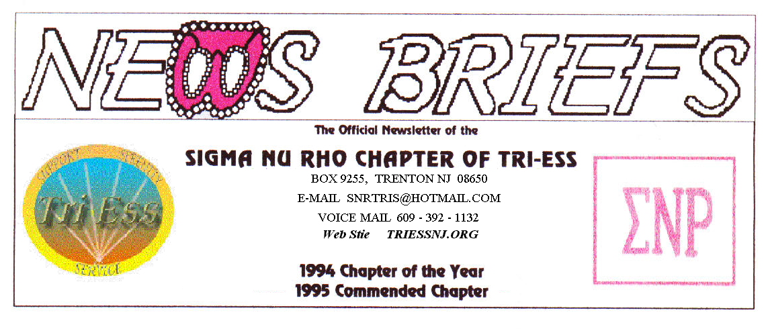
Published Aug 2010
Pool Party?

POOL
The pool is open, so bring your suits.
NJ Support
The NJSG meeting will meet on Sept. 4. That is on Labor Day weekend.
Pathways
The September meeting should be back at the regular meeting place.
King of Prussia
The meeting was fairly normal. The program was on TS surgery.
September will be their annual cook out.
FIFTH SATURDAY
The next fifth Saturday will be in October the day before Halloween.
Health!
The health news is bad as usual. Leah will be out for several months due to foot surgery. Ronnie is not well, and my wife is much worse.
Let’s hope that all recover soon and nobody joins the ranks of the ill.

Pat at Sea
No, the boat was not called the “Sea Witch”

New Members??
If there is one area in which I fail, it is the area of membership. We do not seem to be getting any membership inquires by email, and the inquires we get all seem to be from girls who can’t get to the meeting due to business problems. It is nice to know that they are still working, but this does not help the meeting attendance. Our phone gets mostly telemarketing. Leah will be checking this.
I do not use any Internet chatrooms, and these might be a way to get new members. If any of you can help, please let me know
Discount Voucher Code
Voucher Code to use on www.GlamourBoutique.com whenever you wish to place an order is:
PC10
There is no minimum; no date expiration and our members can use the code over and over. The Code should be ordered when checking out - there's a Voucher field and once you add in the Code the deduction will be made. Alternatively, we have our phones open 7 days a weeks and girls are free to call us on 1-888 721 8688 to place orders or to ask any questions regarding sizing or anything else.

www.GlamourBoutique.com
Tel: 973 226 5588 Fax: 973 226 5589
Programs
ANY IDEAS????
Maybe we could do a field trip. Is there anyplace nearby worth going to? Becky was talking about golf, would this work? The pool should be ready soon and could be fun (wet tee shirts) or maybe a fancy dress night.

MEETING DATES
Aug. 7 New Jersey Support
Aug. 14 Pathways – No regular meeting
Renaissance - Delaware
Renaissance - Lehigh Valley
Aug. 21 Renaissance King of Prussia
Aug. 28 Sigma Nu Rho
Sept. 4 New Jersey Support
Sept. 11 Pathways – Meetings resume
Renaissance - Delaware
Renaissance - Lehigh Valley
Sept. 18 Renaissance King of Prussia
Sept. 25 Sigma Nu Rho

HUMOR

A lonely widow, age 70, decided that it was time to get married again. She put an ad in the local paper that read:
Husband Wanted:
Must be in my age group (70’s).
Must not beat me,
Must nor run around on me
Must still be good in bed!!!
All applicants please apply in person.

On the second day she heard the doorbell.
Much to her dismay, she opened the door to see a gray-haired gentleman sitting in a wheelchair.

He had no arms or legs.

The old women said, you’re not really asking me to consider you are you? Look at you… you have no legs!

The old man smiled, “Therefore, I cannot run around on you!”

She snorted. “ You don’t have any arms either!

Again the old man smiled, “Therefore, I can never beat you!”

She raised an eyebrow and asked intently, “Are you still good in bed?”

The old man leaned back, beamed a big smile and said, “Rand the doorbell didn’t I?”

