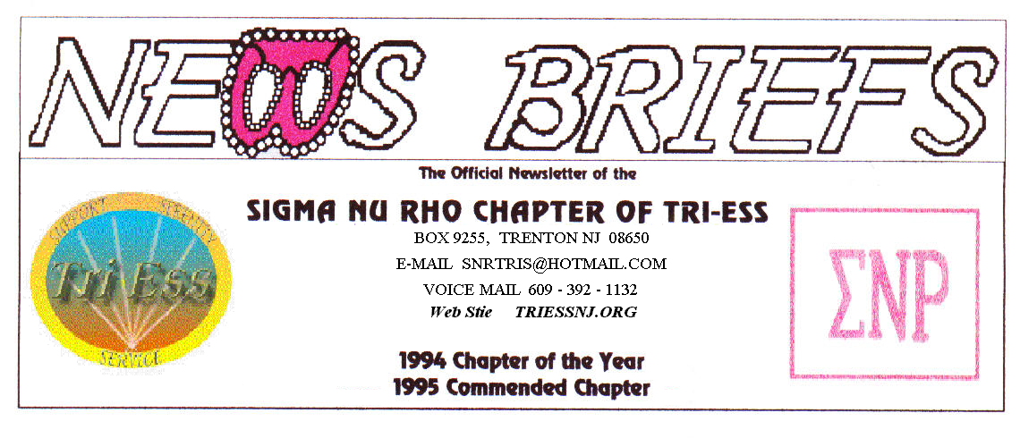
Published Sept. 2014
Fall is Here!

December Party
Come to the party December 13. I will not accept any excuse. If your ex is getting married that day, don’t go, just sent the groom a condolence card and the name and address of a good divorce lawyer. Also remember to stop the alimony checks.
I hope to have the menu options ready and discuss plans.

In the event of any question about a meeting for SNR or New Jersey Support, call 609-392-1132 for a recorded message. If the meeting is to be cancelled, there will be a recorded message to that effect.
REMEMBER
609-392-1132
FOR MEETING INFORMATION
Web Page
Stacy has rebuilt the web page on a new site. At this time some of the old links might not work, but the triessnj.org still works. Take a look at it and tell her what you think.
A BIG thank you to Stacy.
FIFTH SATURDAY
A Fifth Saturday is coming in November, any ideas of what to do?

New members
If you contact anyone who might want to come to a meeting, remember the basic requirement is that you meet them before you tell them where we meet. Any member can bring a guest or prospective new member but you must meet them in person first.
NJ Support
Several new faces this month along with the regular members. Progress with the church was reported and all were reminder that there will be no meeting in December.
Pathways
The September meeting was a return of Lady Ellen. She explained some fashion tips and the new Fall Fashions. From the bright colors and wild patterns of the runway models, I guess they are for use ay airports to show the pilots where the runways are located on dark nights.
King of Prussia
The cookout had a small turnout do to the party at the Raven. There was nothing new or exciting to report.
Next month is the Halloween meeting.

Glamour Boutique

Voucher Code to use on www.GlamourBoutique.com whenever you wish to place an order is:
PC10
There is no minimum; no date expiration and our members can use the code over and over. The Code should be ordered when checking out - there's a Voucher field and once you add in the Code the deduction will be made. Alternatively, we have our phones open 7 days a weeks and girls are free to call us on 1-888 721 8688 to place orders or to ask any questions regarding sizing or anything else.
www.GlamourBoutique.com
Tel: 973 226 5588 Fax: 973 226 5589

MEETING DATES

Sept 27 Sigma Nu Rho

Oct 4 New Jersey Support
Oct 11 Pathways
Renaissance - Delaware
Renaissance - Lehigh Valley
Oct 18 Renaissance King of Prussia
Oct 25 Sigma Nu Rho
Oct 31 Halloween

HUMOR

London cab drivers answer to a request from a Muslim to turn off the radio.
(You just got to love the Brits.)
A devout Arab Muslim entered a black cab in London . He curtly asked the cabbie to turn off the radio because as decreed by his religious teaching, he must not listen to music because in the time of the prophet there was no music, especially Western music which is the music of the infidel.
The cab driver politely switched off the radio, stopped the cab and opened the door.
The Arab Muslim asked him, "What are you doing?"
The cabbie answered, "In the time of the prophet there were no taxis, so piss
off and wait for a camel."

HUMOR

Four Husbands

The local news station was interviewing
an 80-year-old lady because she had just gotten married for the fourth time. The interviewer asked her questions about her life, about
what it felt like to be marrying again at 80, and then about her new husband's occupation.

"He's a funeral director," she answered.

"Interesting," the newsman thought.

He then asked her if she wouldn't mind telling him a little about her first three husbands and what they did for a living. She paused for a few moments, needing time to reflect on all those
years. After a short time, a smile came to her face and she answered proudly, explaining that she had first married a banker when she was in her 20's, then a circus ringmaster when in her 40's, and a preacher when in her 60's, and now
- in her 80's - a funeral director.

The interviewer looked at her, quite astonished, and asked why she had married four men with such diverse careers.

She smiled and explained, "I married one for the money, two for the show, three to get ready, and four to go."

